The Orchid Arcade

Contents

1. Description of the Application 1

Overview 2

Definitions 2

Product Functions 2

User Classes and Characteristics 2

2. Detailed Description and Use Cases 3

User Use Cases 3

Developer/Publisher Use Cases 5

Table of Figures

Figure 1 User and developer general use case 3

Figure 2 User account management use case 3

Figure 3 Browsing and purchasing games use case 4

Figure 4 User library management use case 5

Figure 5 Developer game publishing and management use case 5

# 1. Description of the Application

## Overview

"The Orchid Arcade" (TOA) is a web-based game distribution platform designed to offer a curated selection of cozy and relaxing games. It serves both gamers and indie developers by providing a marketplace where users can purchase, download, and play games, while developers can publish and manage their games. The platform supports various functionalities, including user management, game management, secure transactions, game updates, and community engagement through reviews and ratings.

## Definitions

* **User**: A person who uses the platform to browse, buy, download, and play games.
* **Developer/Publisher**: A person or entity that publishes games on the platform and manages their game listings.

## Product Functions

The primary functions of "The Orchid Arcade" include:

* **User Management**: Account creation, login, and profile management for users and developers.
* **Game Store**: Browsing, searching, and purchasing games by genre, price range, publisher, etc.
* **Game Library**: Downloading, installing, and updating purchased games.
* **Game Publishing**: Developers can upload, manage, and update their games, including descriptions and pricing.
* **Community Features**: Users can leave reviews and rate games to help others in their purchasing decisions.

## User Classes and Characteristics

* **Users**: Casual gamers interested in cozy and relaxing games. Capabilities include account management, browsing and purchasing games, managing game libraries, and engaging in community features.
* **Developers/Publishers**: Indie game developers and publishers aiming to list their games on the platform. They require access to publishing tools, sales analytics, and community engagement options.

# 2. Detailed Description and Use Cases

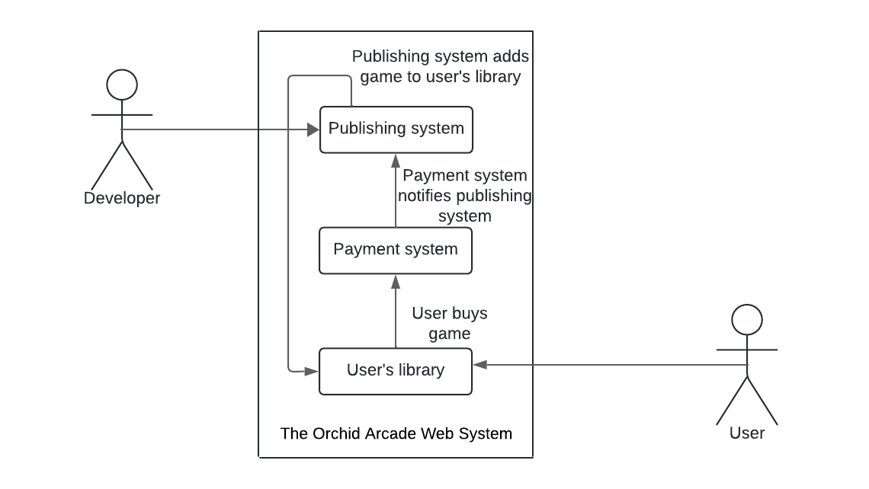

Figure 1 User and developer general use case

## User Use Cases

* **Account Management**:

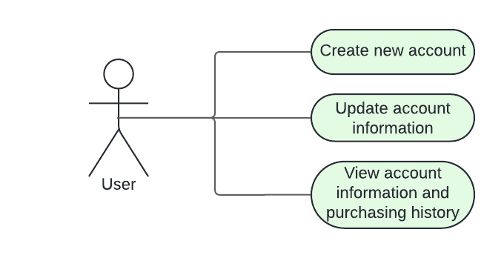

Figure 2 User account management use case

The Orchid Arcade will allow users to:

* + Create, edit, and delete their accounts.
  + Manage their profiles, including changing passwords and updating personal information.
  + View their purchase history and transaction details.

Alternate and error Flows:

* + If the email provided during account creation is already registered, the system prompts the user to log in or use a password recovery process.
  + If there is an issue while attempting to create, delete or update an account (e.g., server error or network issue), the system shows an error message and suggests trying again later.
* **Browsing and Purchasing Games**:

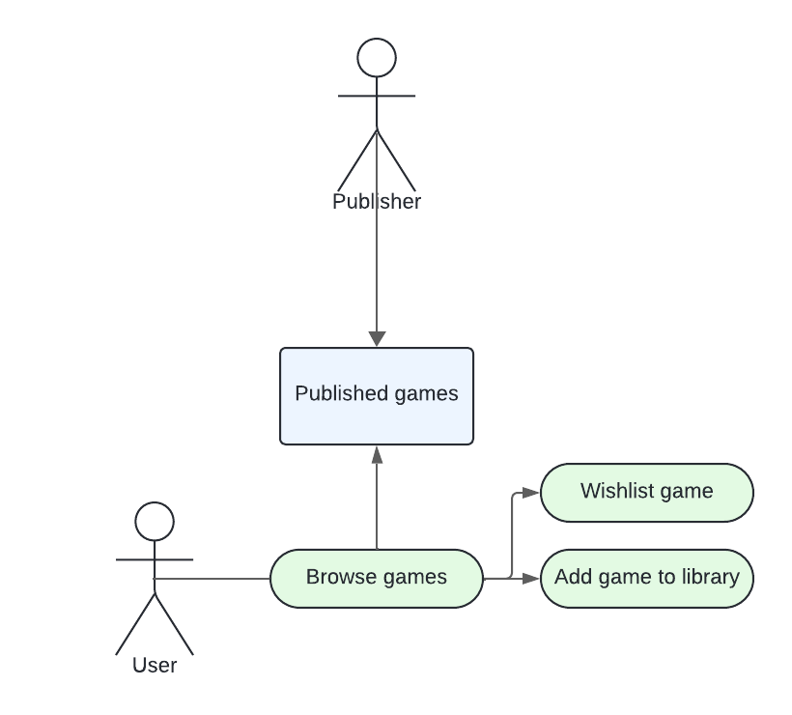

Figure 3 Browsing and purchasing games use case

The Orchid Arcade will allow users to:

* + Browse and search for games by genre, popularity, new releases, and developer.
  + View detailed game pages with descriptions, screenshots, reviews, and ratings.
  + Purchase games using secure payment methods.
  + Add games to a wishlist for future purchases.

Alternate and error Flows:

* + If the user attempts to purchase a game but has insufficient funds or the payment method is declined, the system prompts them to add a different payment method or check their balance.
  + If the user tries to add a game to the wishlist that is already owned, the system displays a notification indicating that the game is already in their library.
  + If an error occurs while processing the payment, the system notifies the user of the failure and suggests attempting the transaction again later.
* **Game Library Management**:

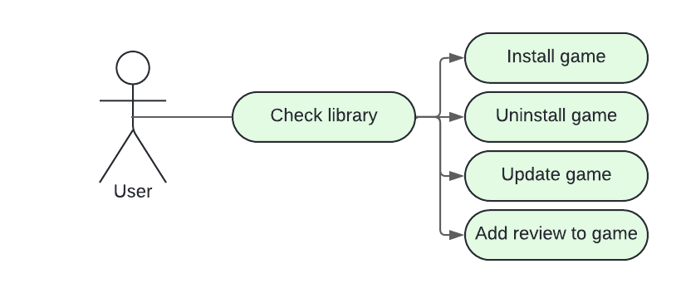

Figure 4 User library management use case

The Orchid Arcade will allow users to:

* + Download, install, and uninstall purchased games.
  + Update games when new versions are released.
  + View and manage their game library.

Alternate and error Flows:

* + If a game download is interrupted due to a network error, the system pauses the download and provides an option to retry.
  + If the user tries to download a game but doesn't have enough disk space, the system displays an error message and suggests freeing up space.
* **Community Engagement**:  
  The Orchid Arcade will allow users to:
  + Leave reviews and ratings for games they have purchased.

## Developer/Publisher Use Cases

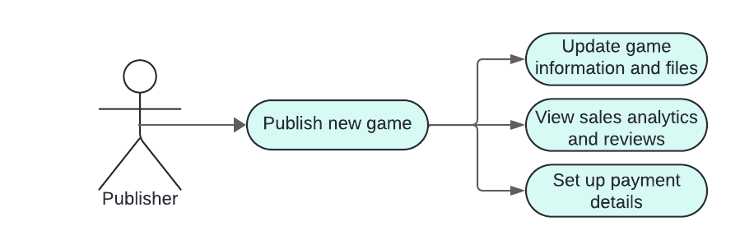

Figure 5 Developer game publishing and management use case

* **Game Publishing and Management**:

The Orchid Arcade will allow developers/publishers to:

* + Create a developer/publisher profile.
  + Upload and publish their games, including game files, descriptions, screenshots, and trailers.
  + Manage their published games, including updating game files, descriptions, and prices.
  + View sales analytics and user feedback to improve their games.
  + Engage with users by responding to reviews and comments.

Alternate and error Flows:

* + If the uploaded game file format is not supported, the system notifies the developer to upload a file in an acceptable format.
  + If the developer inputs an invalid price format, the system displays an error and prompts them to enter a valid price.
* **Sales and Revenue Management**:

The Orchid Arcade will allow developers/publishers to:

* + Set up payment details.
  + View sales reports and revenue generated from their games.

Alternate and error Flows:

* + If an error occurs while generating the sales report, the system displays an error message and provides an option to retry after some time.

# References:

* Lane, G. K. C. (2023, January 17). How to write an SRS Document (Software Requirements Specification Document). Perforce Software. <https://www.perforce.com/blog/alm/how-write-software-requirements-specification-srs-document>
* TianyaoHan. (n.d.). GitHub - TianyaoHan/Steam-Recommendation-System: Steam Database Design and Game Recommendation System. GitHub. https://github.com/TianyaoHan/Steam-Recommendation-System